Michael Dang – 16257750

STAT5572

Exam 2

11/28/2023

1. Code

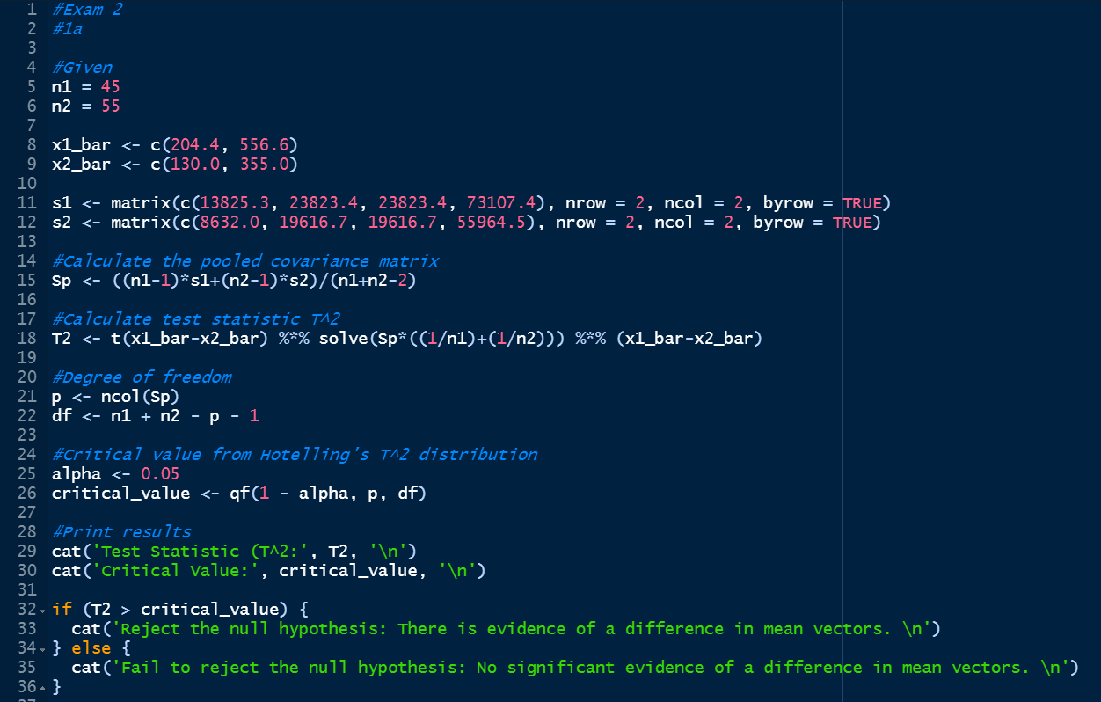

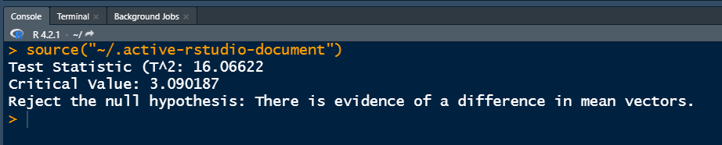

1. Code

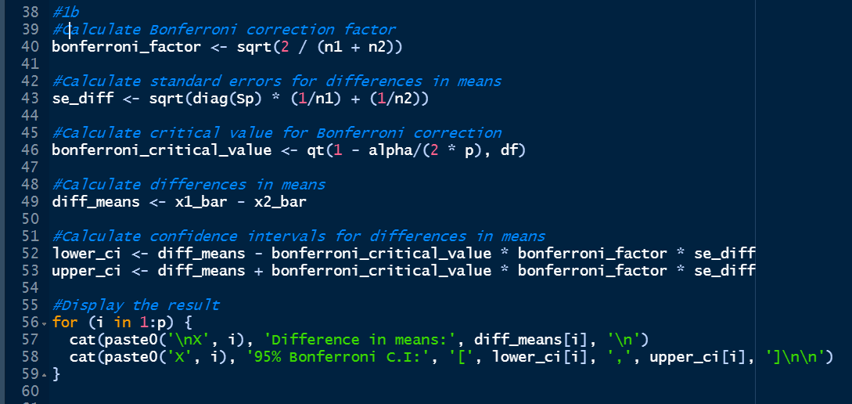

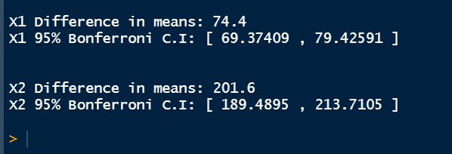

1. 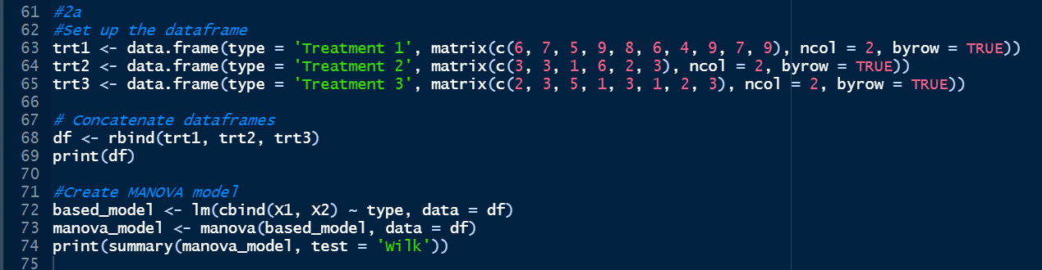Code

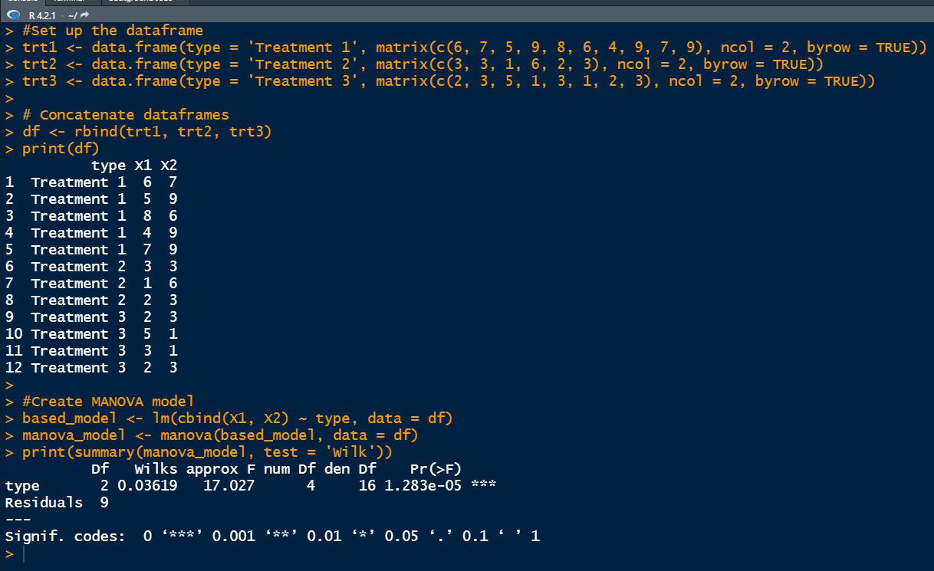

The Wilks’s test statistics is 0.03619 and the p-value is 0.00001.

Hence, we have evidence to reject the null hypothesis.

Therefore, there is evidence of a difference in mean vectors.

1. 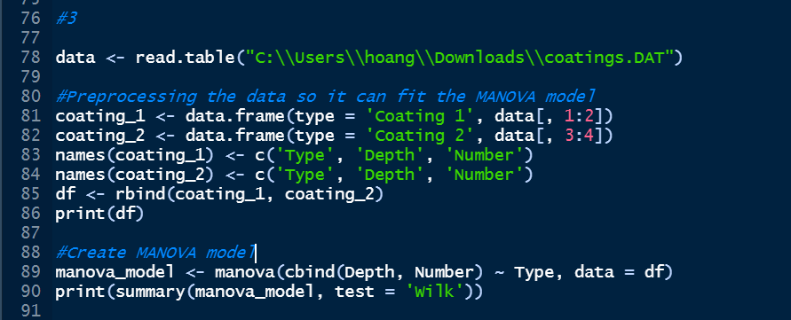

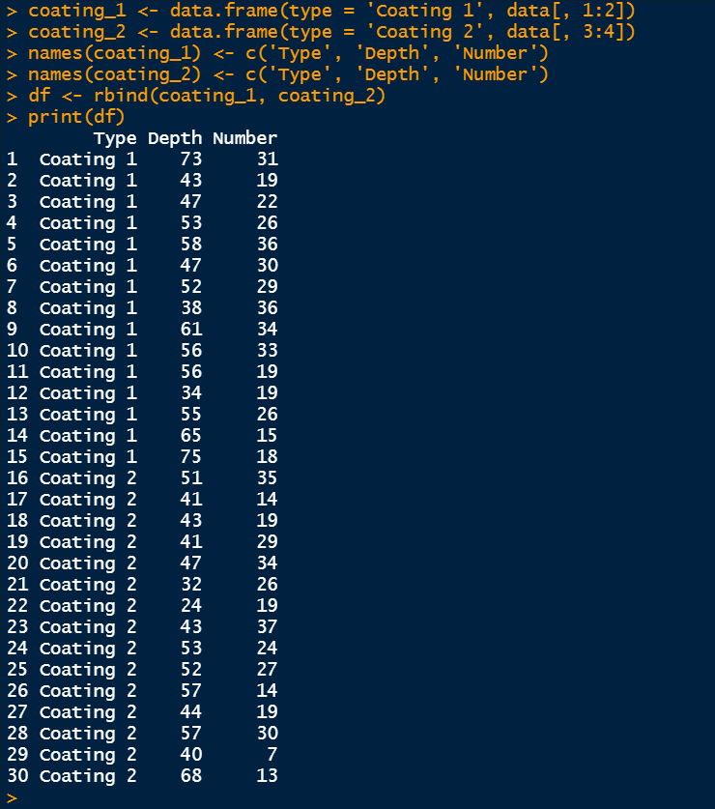

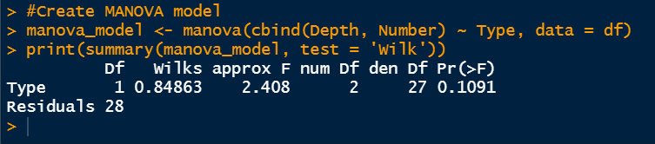

The Wilks’s test statistics are

0.84863 and the p-value is 0.1091.

Hence, we don’t have enough evidence to reject the Null hypothesis.

Therefore, there is evidence that the two coatings mean are equal in their effect on corrosion.